Here are some resources to help you

Grammar of Graphics to understand the dimensions of visuals.

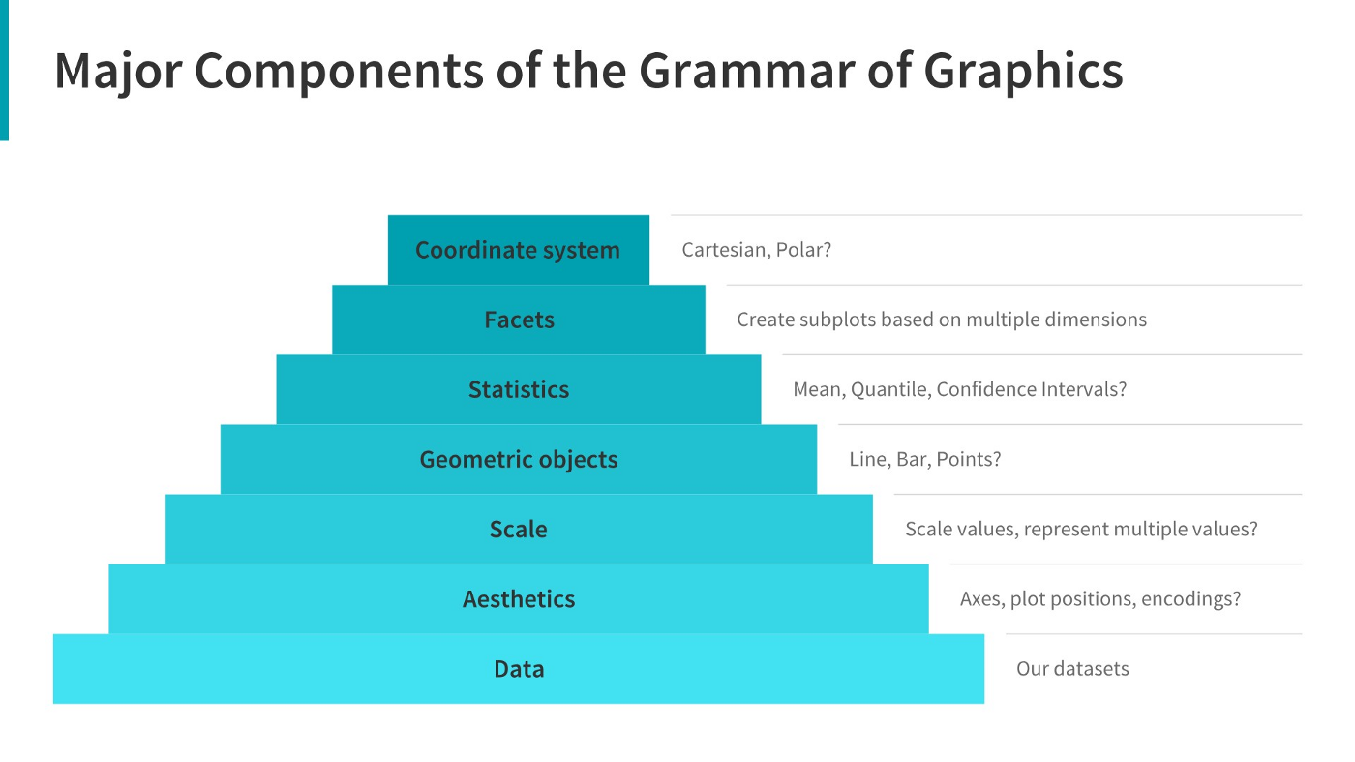

**• A Comprehensive Guide to the Grammar of Graphics**

**Click to view website →**

[**https://towardsdatascience.com/a-comprehensive-guide-to-the-grammar-of-graphics-for-effective-visualization-of-multi-dimensional-1f92b4ed4149**](https://towardsdatascience.com/a-comprehensive-guide-to-the-grammar-of-graphics-for-effective-visualization-of-multi-dimensional-1f92b4ed4149)

**• How to Choose the Right Chart for Data Visualization**

**Click to view website →**

[**https://www.analyticsvidhya.com/blog/2021/09/how-to-choose-the-right-chart-for-data-visualization/**](https://www.analyticsvidhya.com/blog/2021/09/how-to-choose-the-right-chart-for-data-visualization/)

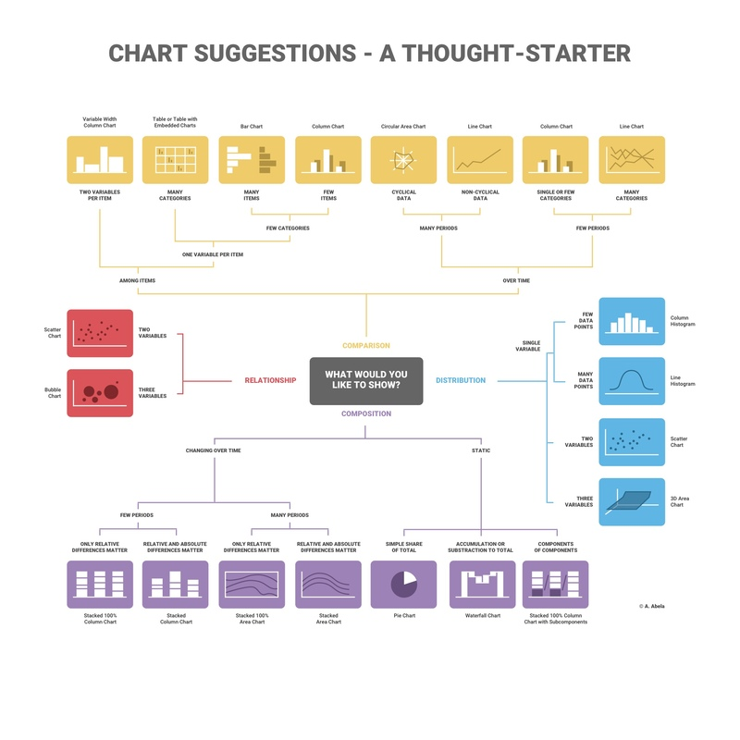

**• How to Choose the Right Chart for Your Data**

**Click to view website →**

[**https://infogram.com/page/choose-the-right-chart-data-visualization**](https://infogram.com/page/choose-the-right-chart-data-visualization)

**• Additional Resources:**

**• Ultimate Guide to Choosing the Right Visual**

**Click to view website →**

[**https://towardsdatascience.com/ultimate-guide-to-choosing-the-right-visual-2a77aa8eec08**](https://towardsdatascience.com/ultimate-guide-to-choosing-the-right-visual-2a77aa8eec08)

**• How to Choose the Right Data Visualization**

**Click to view website →**

[**https://chartio.com/learn/charts/how-to-choose-data-visualization/**](https://chartio.com/learn/charts/how-to-choose-data-visualization/)

**• Which Type of Chart or Graph is Right for You?**

**Click to view website →**

[**https://www.tableau.com/learn/whitepapers/which-chart-or-graph-is-right-for-you**](https://www.tableau.com/learn/whitepapers/which-chart-or-graph-is-right-for-you)